CUBE – UI BLOCK MATRIX



Document ID | DigDev_Cube_UI_Block_Matrix_v1.0
Product | Cube
Environment | All
Confidentiality Level | Internal / Restricted

Contents
1 DOCUMENT INFORMATION 3
1.1 Validation 3
1.2 Document Distribution 3
1.3 Version Control 3
2 PURPOSE & CONTEXT 4
2.1 About this document 4
2.2 Scope 4
2.3 Roles & Responsibilities 4
2.4 Terminology 5
2.5 Conventions Used 5
3 CUBE UI block matrix 6
3.1 Standard Record Page Layout 6
3.2 Always-Present Blocks 6
3.2.1 Main Info Block 6
3.2.2 Users Block 7
3.3 Relationship Blocks 7
3.3.1 Parent Block 7
3.3.2 Children Block 7
3.4 Supporting UI Blocks 7
3.5 Block Placement Logic 9
3.6 How to Read the Matrix 9
3.7 Complexity levels 9
3.8 Example: Service Providers 10
3.9 Matrix References 10
4 APPROVAL SIGNATURES 11

DOCUMENT INFORMATION

Validation
Name |  | Role | Date (dd/mm/aa)
Issued by | Oscar Rondon | Technical Writer | 14/06/2026
Verified by
Approved by | Anthony Bures | Digital Development Manager | 14/06/2026

Document Distribution
Normal | Role
Oscar Rondon | Technical Writer
Anthony Bures | Digital Development Manager

Version Control
Version | Date | Author | Description of changes
1.0 | 14/06/2026 | Oscar Rondon | 1st version of the Cube UI Block Matrix document

PURPOSE & CONTEXT

About this document
This document describes how to read, maintain, and use the CUBE UI Blocks Matrix. The matrix is used as a reference to identify which UI components, record relationships, and supporting sections may be required for each CUBE module or table.
The purpose of this SOP is to provide a consistent method for interpreting the matrix so that team members can understand the expected complexity of each module, identify reusable UI blocks, and support design, development, documentation, and review activities related to the CUBE application.

Scope
This SOP applies to the review and documentation of the CUBE UI Blocks Matrix.
In scope:
- CUBE modules and tables listed in the UI Blocks Matrix.
- UI block classification for CUBE pages.
- Parent and child record relationships shown in the matrix.
- Page complexity classification, such as simple, moderate, or high.
- Special considerations documented for each module or table.
- Reusable UI blocks such as statuses, workflows, documents, tasks, approvals, maps, service information, rates, and financial information.
Out of scope:
- Detailed functional requirements for each CUBE module.
- Development or technical implementation of UI components.
- Backend logic, database structure, or API behavior.
- User training procedures for completing tasks inside CUBE.
- Final approval of application design or business rules.
- Modules, applications, or environments not included in the CUBE UI Blocks Matrix.

Roles & Responsibilities
Role | Responsibilities
Business Stakeholder | Confirms the meaning of the matrix entries and validates whether the documented UI blocks reflect the expected business needs.
UI/UX Designer | Uses the matrix to identify layout needs, reusable components, and page complexity when designing CUBE screens.
Developer | Uses the matrix as a reference to understand which UI sections or reusable blocks may be required for each module.
QA / Tester | Uses the matrix to understand expected page elements and support test scenario creation or validation.
CUBE Administrator | Reviews the matrix when system configuration, module visibility, or access-related considerations need to be confirmed.

Terminology
Term Used | Description
CUBE | Internal ZTERS application used to manage customer, sales, operational, user, administrative, and reporting information.
UI Blocks Matrix | Reference table used to identify the UI components, relationships, complexity, and special considerations associated with CUBE modules or tables.
Module | A functional area or page in CUBE used to manage a specific type of information, such as Service Providers, Customers, Sites, or VM Tickets.
Table | A structured set of records in CUBE. In the matrix, each row usually represents a table or record type that may require a specific UI layout.
Parent Record | A main record that another record belongs to or depends on. For example, a contact may belong to a service provider.
Child Record | A related record displayed under or associated with a parent record. For example, documents or tasks may be child records of another module.
UI Block | A reusable section or component that can appear on a CUBE page, such as documents, tasks, approvals, maps, statuses, rates, or financial information.
Complexity | A classification used to indicate how detailed or structured a page is expected to be. Complexity may be simple, moderate, or high.
Special Considerations | Notes that describe unique behavior, workflows, integrations, or design needs for a specific module or table.
Status Block | A UI block that shows the current state of a record, workflow, or process.
Workflow / Checklist Block | A UI block used to guide users through required steps, sequences, or operational actions.
Documents Block | A UI block used to display or manage documents related to a record, such as COI, W9, contracts, or other supporting files.
Tasks Block | A UI block used to display or manage work items associated with a record.
Approval Block | A UI block used when a record or action requires review, validation, or approval.
Financial Block | A UI block used to display pricing, rates, margins, revenue, costs, or other financial information.

Conventions Used
The following structures are used as recommendations.
Info: Supplementary Information

Tip: A recommendation or useful advice

Warning: A warning or important notice

Note: A notice.

CUBE UI block matrix
The CUBE UI Block Matrix is used to identify repeatable UI patterns across CUBE modules and tables. Its purpose is to help the team determine which sections, components, and supporting blocks may be required when designing or documenting a CUBE record page.
The matrix is not intended to define every field that appears on a page. Instead, it helps identify common layout needs across the application, such as parent information, child records, statuses, workflows, documents, approvals, dates, logs, maps, and financial information. By identifying these patterns, the team can define reusable UI blocks and apply them consistently across CUBE.

Standard Record Page Layout
A cube record page is expected to follow a consistent layout whenever possible. The layout is organized around core record information, related records, and supporting UI blocks.
- The Main Info block contains the primary information for the record. This is the main section users review or update when working with a record.
- The Users block contains user-related information associated with the record. This may include the record creator, record owner, last updated by, assigned users, approvers, or other users connected to the record.
- The Parents block displays information from records that the current record depends on. For example, a service ticket may need to show customer, site, product, or service provider information. This allows users to understand the record context without opening each parent record separately.
- The Children block displays important related records connected to the current record. These are usually the child records that users need to review most often from the main page. Other related records may still be available in tabs or secondary sections, but the most important child records should be easier to access.
Supporting blocks are displayed when they are relevant to the module. These may include status, checklists, dates, logging, approvals, documents, maps, rates, margins, or other specialized sections.

Always-Present Blocks
Some blocks are expected to appear on every CUBE record page.

Main Info Block
The Main info block is the primary content area of the record page. It contains the key fields that define the record and allow users to review or maintain the main record information.
This block should remain central in the page layout because it represents the main purpose of the record. Other blocks may appear around it depending on the module, but the main info block remains the main working area.

Users Block
The Users block displays the users and system ownership information associated with the record. This may include who created the record, who last updated it, who owns it, and any additional assigned users required by the module.
When dates are directly tied to user actions, such as created date, updated date, or approved date, those dates may also be grouped with the related user information. This keeps systems ownership and timestamp information together in one consistent area.

Relationship Blocks
Relationship blocks are used when a record is connected to other records in CUBE.

Parent Block
The Parents block displays key information from parent records. A parent record is a record that the current record depends on or belongs to.
For example, a service ticket may be linked to a customer, site, product, or service provider. Instead of showing only records IDs, the Parents block should provide useful context, such as the customer name, site address, provider name, or other important lookup information.
This block helps users understand the record without requiring them to navigate away from the page.

Children Block
The Children block displays important related records under the current record. These are records that depend on or are linked to the current record.
For example, a product record may have related service tickets, fulfillment tickets, notes, or documents. When one or two child record types are specially important to the user’s workflow, they may be displayed directly on the main page instead of being placed only in tabs.
The Children block should prioritize the related records that users need to access most often.

Supporting UI Blocks
Supporting UI blocks are added when a module requires additional information or workflow support. These blocks are not required for every page, but they should be used consistently when applicable. The following table summarizes the most common supporting blocks and their purpose.
UI Block | Used When | Example Information
Status Block | The record has one or more important statuses. | Authorized, pending approval, ready for invoicing, stalled.
Workflow/Checklist Block | The record has required steps or completion requirements. | COI received, W9 received, approval completed, onboarding steps.
Dates Block | The record has several important operational dates. | Delivery date, service date, removal date, expiration date.
Loggin Block | Specific business actions must be tracked. | Document uploaded, authorization changed, compliance updated.
Approval Block | The record requires review or authorization. | Requested by, approved by, approval date, approval status.
Documents Block | The record has related files or compliance documents. | COI, W9, contracts, proof of insurance.
Maps / Address Block | Location or service area information is important. | Site address, service zone, pricing area, map view.
Financial / Rates / Margins Block | The record includes financial or pricing information. | Rates, costs, revenue, margin, pricing details.

After identifying the applicable supporting blocks in the matrix, the page can be organized so that related information appears in a predictable location across CUBE modules.
Tip: The following is a UI block example taken from the official CUBE UI design block mockups. It shows how the Documents block can display related files, document types, upload details, and available actions in a reusable format across CUBE record pages.

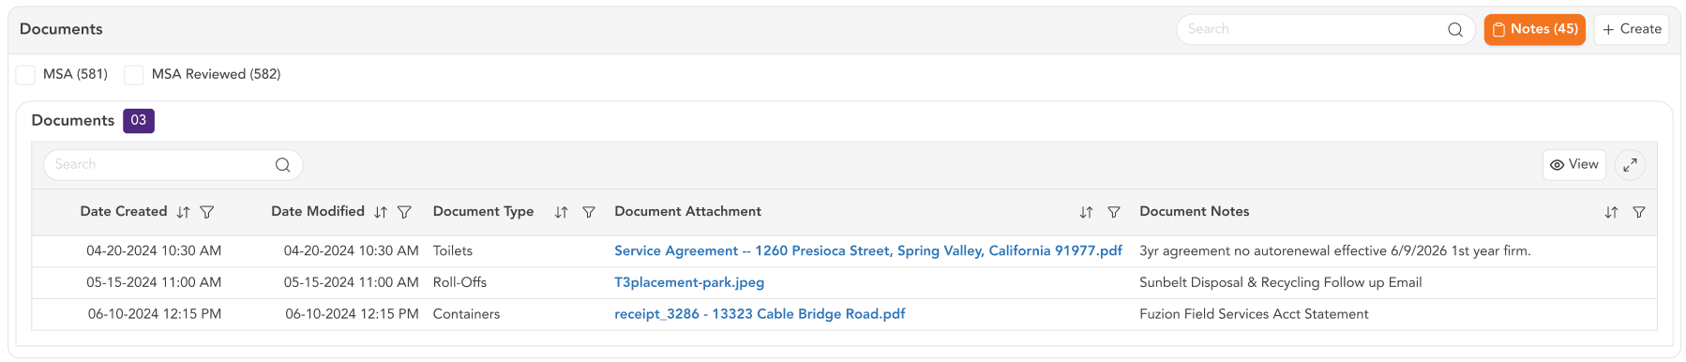
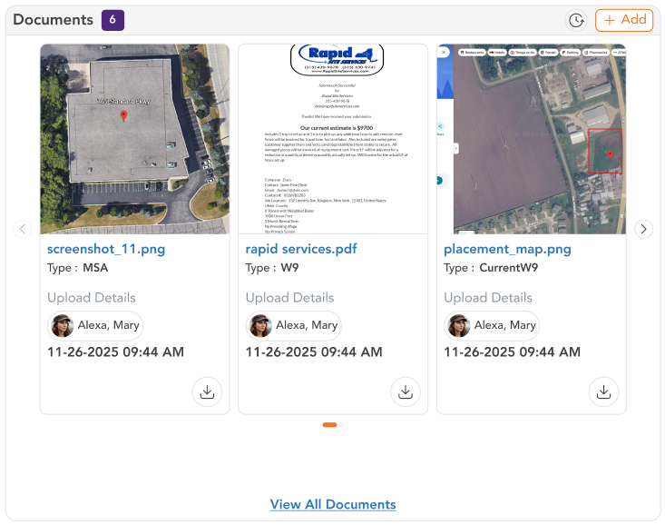

Block Placement Logic
The Cube record page layout should remain as consistent as possible across modules. The Main info and Users blocks are the most stable blocks because they are expected to appear on every record page.
Other blocks may appear on shift depending on the module. For example, a record may have a status block but no Parents block, or it may have Documents and Approvals but no Maps block.
When a supporting block is important to the user’s workflow, it should be placed near the top of the page whenever possible. Status and Workflow / Checklist information should be easy to find because these blocks help users understand what needs attention.
The placement does not need to be identical on every page, but similar information should appear in a predictable area. This helps users move between CUBE modules without having to relearn each page layout.

How to Read the Matrix
Each row in the matrix represents a CUBE module, table, or record type. The row identifies which UI blocks may be needed for that page. To read the matrix:
- Start with the table or module name.
- Then review whether the record has parent records, important child records, and any special UI considerations.
- After that, review the block columns to determine which supporting sections may be required.
A selected value means that the block or behavior is expected for that module. A blank value means that the block has not been identified as required for that module.
The matrix should be read as a planning reference. It helps the team understand the expected layout and complexity of a page before design, development, testing, or documentation work begins.

Complexity levels
The complexity value indicates how much layout and workflow support a page may require.
A Simple page usually requires basic record information and limited supporting sections. These pages may only need the Main info block, Users block, and standard table actions.
A Moderate page may require additional structure, such as parent information, important child records, statuses, documents, tasks, or other supporting blocks.
A High complexity page may require several UI blocks, multiple related records, heavy data-entry sections, workflows, approvals, logging, maps, financial information, or special design considerations.
High-complexity pages should receive additional review because they usually require more detailed design, testing, and documentation.

Example: Service Providers
The Service Providers module is a high-complexity page because it includes several types of information beyond the main providers’ details.
A service provider is a top level record, so it does not require a Parents block in the same way that a child record would. However, it may require multiple supporting blocks, such as status, checklist, documents, logging, approvals, rates, and financial information.
This means the Service Providers page should not be treated as a simple form. It may require a structured layout that separates provider details, compliance information, operational status, documentation, rates, and other supporting information into clear UI blocks.

Matrix References
- Csv Cube UI Blocks file: https://zters-my.sharepoint.com/:x:/p/justin_t/IQBnMYHdzRTER67jDjqyrTVQAU6zHMTD9JNjVAfz0LvlXX0?e=fXaCrP
- Figma Cube UI Blocks: https://www.figma.com/design/xELrGsT1AQFn8h5vnJ9VZq/CUBE-Design-System?node-id=2927-29759

APPROVAL SIGNATURES
Digital signature blocks below are formatted for DocuSign / Adobe Sign.
Name | Role | Digital Signature Block | Date (dd/mm/aa)
Anthony Bures | Digital Development Manager |  | 18/06/2026

--- END OF THE DOCUMENT ---

